Curriculum Vitae | 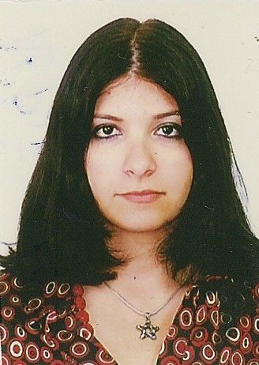
Personal information
First name(s) / Surname(s) | Adriana – Sabina Albuţiu
Address(es) | Str. MUNTENIEI, Bl. C31, Ap. 8, Timisoara, Romania
Telephone(s) | +40 356 427 164 |  |  |  |  | Mobile: |  |  |  | +40 749 279 761
E-mail | adriana.albutiu@gmail.com
Nationality | Romanian
Date of birth | 26/05/1989
Gender | Female
Education and training
Dates | 2008 – present
Title of qualification awarded | Engineering and management
Name and type of organisation providing education and training | Polytechnic University, Timişoara - Management in Production and Transport Faculty
Personal skills and competences
Mother tongue(s) | Romanian
Other language(s) | English, French
Self-assessment |  | Understanding |  |  |  |  | Speaking |  |  |  |  | Writing
European level |  | Listening |  | Reading |  |  | Spoken interaction |  | Spoken production
English |  | C1 | Proficient User | C1 | Proficient User |  | B2 | Independent user | B2 |  | Independent user | B1 | Independent user
French |  | A1 | Basic User | A1 | Basic User |  | A1 | Basic User | A1 |  | Basic User | A1 | Basic User
Social skills and competences | - Team work  - Initiative  - Good communication skills
Organisational skills and competences | During high school I organised 3 editions of international theatre festival in englsh “”T4T””
Computer skills and competences | Competent with most Microsoft Office programmes and some experience with HTML , AutoCAD, Photoshop, Oracle  Certificate in
Driving licence | Category B
Additional information | References available upon request
Annexes | Copy of Cambridge First Certificate in English diploma

