 |  | 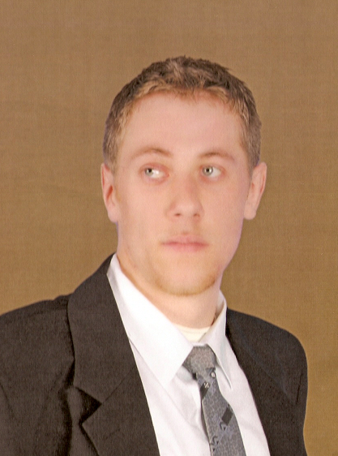
Europass
Curriculum Vitae
Personal information
First name / Surname |  | Boroş Sebastian Ionuţ
Address(es) |  | Str. Dr. Victor Babeş, no. 62/A, Baia Mare, Maramureş  Str. Dr. Florian C Ulmeanu, no. 12, Ulmeni, Maramureş
Telephone(s) |  |  |  |  |  |  | Mobile: |  |  |  | +4 0752455332
E-mail |  | boros.sebastian@yahoo.com
Nationality |  | Romanian
Date of birth |  | 27.04.1987
Gender |  | Male
Education and training
Dates |  | 2011
Title of qualification awarded
Principal subjects/occupational skills covered |  | Materials Science and Engineering, Mechanics, Technical Drawing, Finance and Credit, Mathematical Analysis, Scientific Management, Business Law, Computer Aided Design, Products Manufacturing Technology
Name and type of organisation providing education and training |  | Baia Mare North University, Engineering College
Dates |  | 2006 - 2010
Title of qualification awarded |  | High School Diploma, Mechatronics Licence
Principal subjects/occupational skills covered |  | Technology, Technical Drawing, Mathematics, Romanian Language and Literature, English, French , Physics, Chemistry.
Name and type of organisation providing education and training |  | Dr. Florian Ulmeanu High School, Ulmeni
Personal skills and competences  Mother tongue(s)  Other language(s) |  | Romanian
Self-assessment |  |  | Understanding |  |  |  |  | Speaking |  |  |  |  | Writing
European level (*) |  |  | Listening |  | Reading |  |  | Spoken interaction |  | Spoken production
English |  |  | B2 | Independent user | B2 | Independent user |  | B2 | Independent user | B1 |  | Independent user | B2 | Independent user
French |  |  | A2 | Basic User | B1 | Independent user |  | A1 | Basic User | A1 |  | Basic User | A2 | Basic User
Hungarian |  |  | B2 | Independent user | B1 | Independent user |  | B1 | Independent user | B1 |  | Independent user | A2 | Basic User
 |  | (*) Common European Framework of Reference for Languages
Social skills and competences |  | Team spirit. Since i was in high school, I participated in activities involving teamwork, an effective working way for me. Sociable, communicative.
Organisational skills and competences |  | I can effectively manage a team, taking into consideration the usefull information from their members and after processing, putting them in aplication.
Technical skills and competences |  | I have knowledges and skills in IT, both in software and hardware domain I can change hardware components, I can identify and resolve PC hardware and software problems.
Computer skills and competences |  | A good knowledge in using computers, Windows operating system, Office programs (Word, Excel, PowerPoint), AutoCAD, Inventor, Catia.
Artistic skills and competences |  | Creative, i have a good perspective for graphics.
Other skills and competences |  | Motivated, neat, adaptive in new situations.
Additional information |  | Since from high school i was involved in many educational activities, I like to learn new things, especially in technical and management domains. I`m always open for new knowledges.

