 |  | 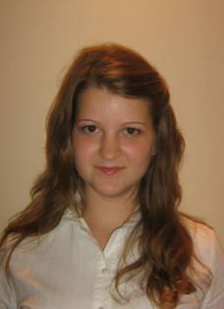
Curriculum Vitae
Personal information
Surname(s) / First name(s) |  | Popescu Paula Andrada
Address(es) |  | Aleea Filaturii 1/34, Baia Mare, Maramureş
Telephone(s) |  | Mobile: |  |  |  |  | 0743340637
E-mail |  | Popescu.d.paula@gmail.com
Nationality |  | Romanian
Date of birth |  | 01.09.1989
Education and training
Dates |  | 2011
Principal subjects/occupational skills covered |  | Materials Science and Engineering, Mechanics, Technical Drawing, Finance and Credit, Mathematical analysis, Scientific Management, Business Law, Computer Aided Design, Products Manufacturing Technology
Name and type of organisation providing education and training |  | Baia Mare North University, Engineering College, Economic Engineering in Mechanical Domain
Dates |  | 2004-2008
Principal subjects/occupational skills covered |  | Mathematics-IT
Name and type of organisation providing education and training |  | C.N. “ Vasile Lucaciu” Baia Mare
Dates |  | 1996-2004
Name and type of organisation providing education and training |  | School Number 18, Baia Mare
Personal skills and competences
Mother tongue(s) |  | Romanian
Other language(s)
Self-assessment |  |  | Understanding |  |  |  |  | Speaking |  |  |  |  | Writing
European level (*) |  |  | Listening |  | Reading |  |  | Spoken interaction |  | Spoken production
English |  |  |  | average |  | average |  |  | beginner |  |  | beginner |  | beginner
French |  |  |  | average |  | average |  |  | average |  |  | average |  | average
Social skills and competences |  | I have teamspirit. I am sociable, communicative.
Organisational skills and competences |  | I have a good capacity of analysis and synthesis and I know how to motivate my team members. These skills help me to manage a team.
Computer skills and competences |  | A good knowledge in using computers, Office programs (Word, Excel, PowerPoint), AutoCAD, Inventor, Catia.
Other skills and competences |  | Motivated, adaptable to new situations

