Curriculum Vitae | 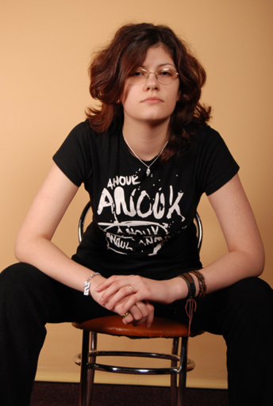
Personal information
First name(s) / Surname(s) | Anca MOCAN
Address(es) | Calea Sagului, no 81, sc A, ap 19, code 300516, Timisoara, Timis
Telephone(s) | 0040724340951
E-mail | ancamocan2003@yahoo.com
Nationality | Romanian
Date of birth | 15/06/1990
Work experience
Dates | October 2009 onwards
Occupation or position held | Administrative personnel
Main activities and responsibilities | Writing, updating and translating information on the firm’s website  Translating business documents  Working on advertising sub-projects.
Name and address of employer | Expert Consulting SRL
Type of business or sector | Management and consultancy
Education and training
  Dates | September 2004-Iulie 2008
  Title of qualification awarded | High school graduate
  Principal subjects/occupational skills covered | Nature science (mathematics, physics, Chemistry and Biology)
  Name and type of organisation providing education and training | Colegiul National Banatean
  October 2008 onwards
  Bachelor degree
  Industrial engineering in mechanics
  Politechnic university, Faculty of management in production and trasnportation
Dates | September 2004-Iulie 2008
Title of qualification awarded | High school graduate
Principal subjects/occupational skills covered | Nature science (mathematics, physics, Chemistry and Biology)
Name and type of organisation providing education and training | Colegiul National Banatean
Personal skills and competences
Mother tongue(s) | Romanian
Other language(s) | English, French, German, Japanese
Self-assessment |  | Understanding |  |  |  |  | Speaking |  |  |  | Writing
European level (*) |  | Listening |  | Reading |  |  | Spoken interaction |  | Spoken production
English |  | C1 | Proficient user | C1 | Proficient user |  | C1 | Proficient user | C1 | Proficient user | C1 | Proficient user
French |  | B2 | Independent user | B2 | Independent user |  | B2 | Independent user | B2 | Independent user | B2 | Independent user
 | team
Social skills and competences | Team work: I have worked in various teams, throughout training and formation at the TREPAN and ISO9001 specialist classes I attended, as well as in my workplace, for various projects I was assigned to.  Intercultural skills: I have participated in 2 international camps, in Taiwan and Norway, with the purpose of enhancing my intercultural skills. I am also currently working on a Public health awareness program with students from both the Romanian and English classes from UMF Timisoara
Organisational skills and competences | Organising events and teams for any number of varied events
Technical skills and competences | Knowledge of the ISO9001 guidelines  Knowledge of international business conduct and intercultural business differences.
Computer skills and competences | Microsoft office (Word. Excel, PowerPoint, Access,Publisher), AutoCAD, Photoshop, Open Office, some HTML.
Artistic skills and competences | Writing short stories, drawing, choir singing, playing guitar
Other skills and competences | Driving licence, type B
Annexes | Cambridge CAE diploma,  DELFB2 diploma  ISO9001 specialist diploma  TREPAN classes participation  Certificate of participation in the formation course “Disseminating the European language portfolio”

