

Europass  Curriculum Vitae |  | 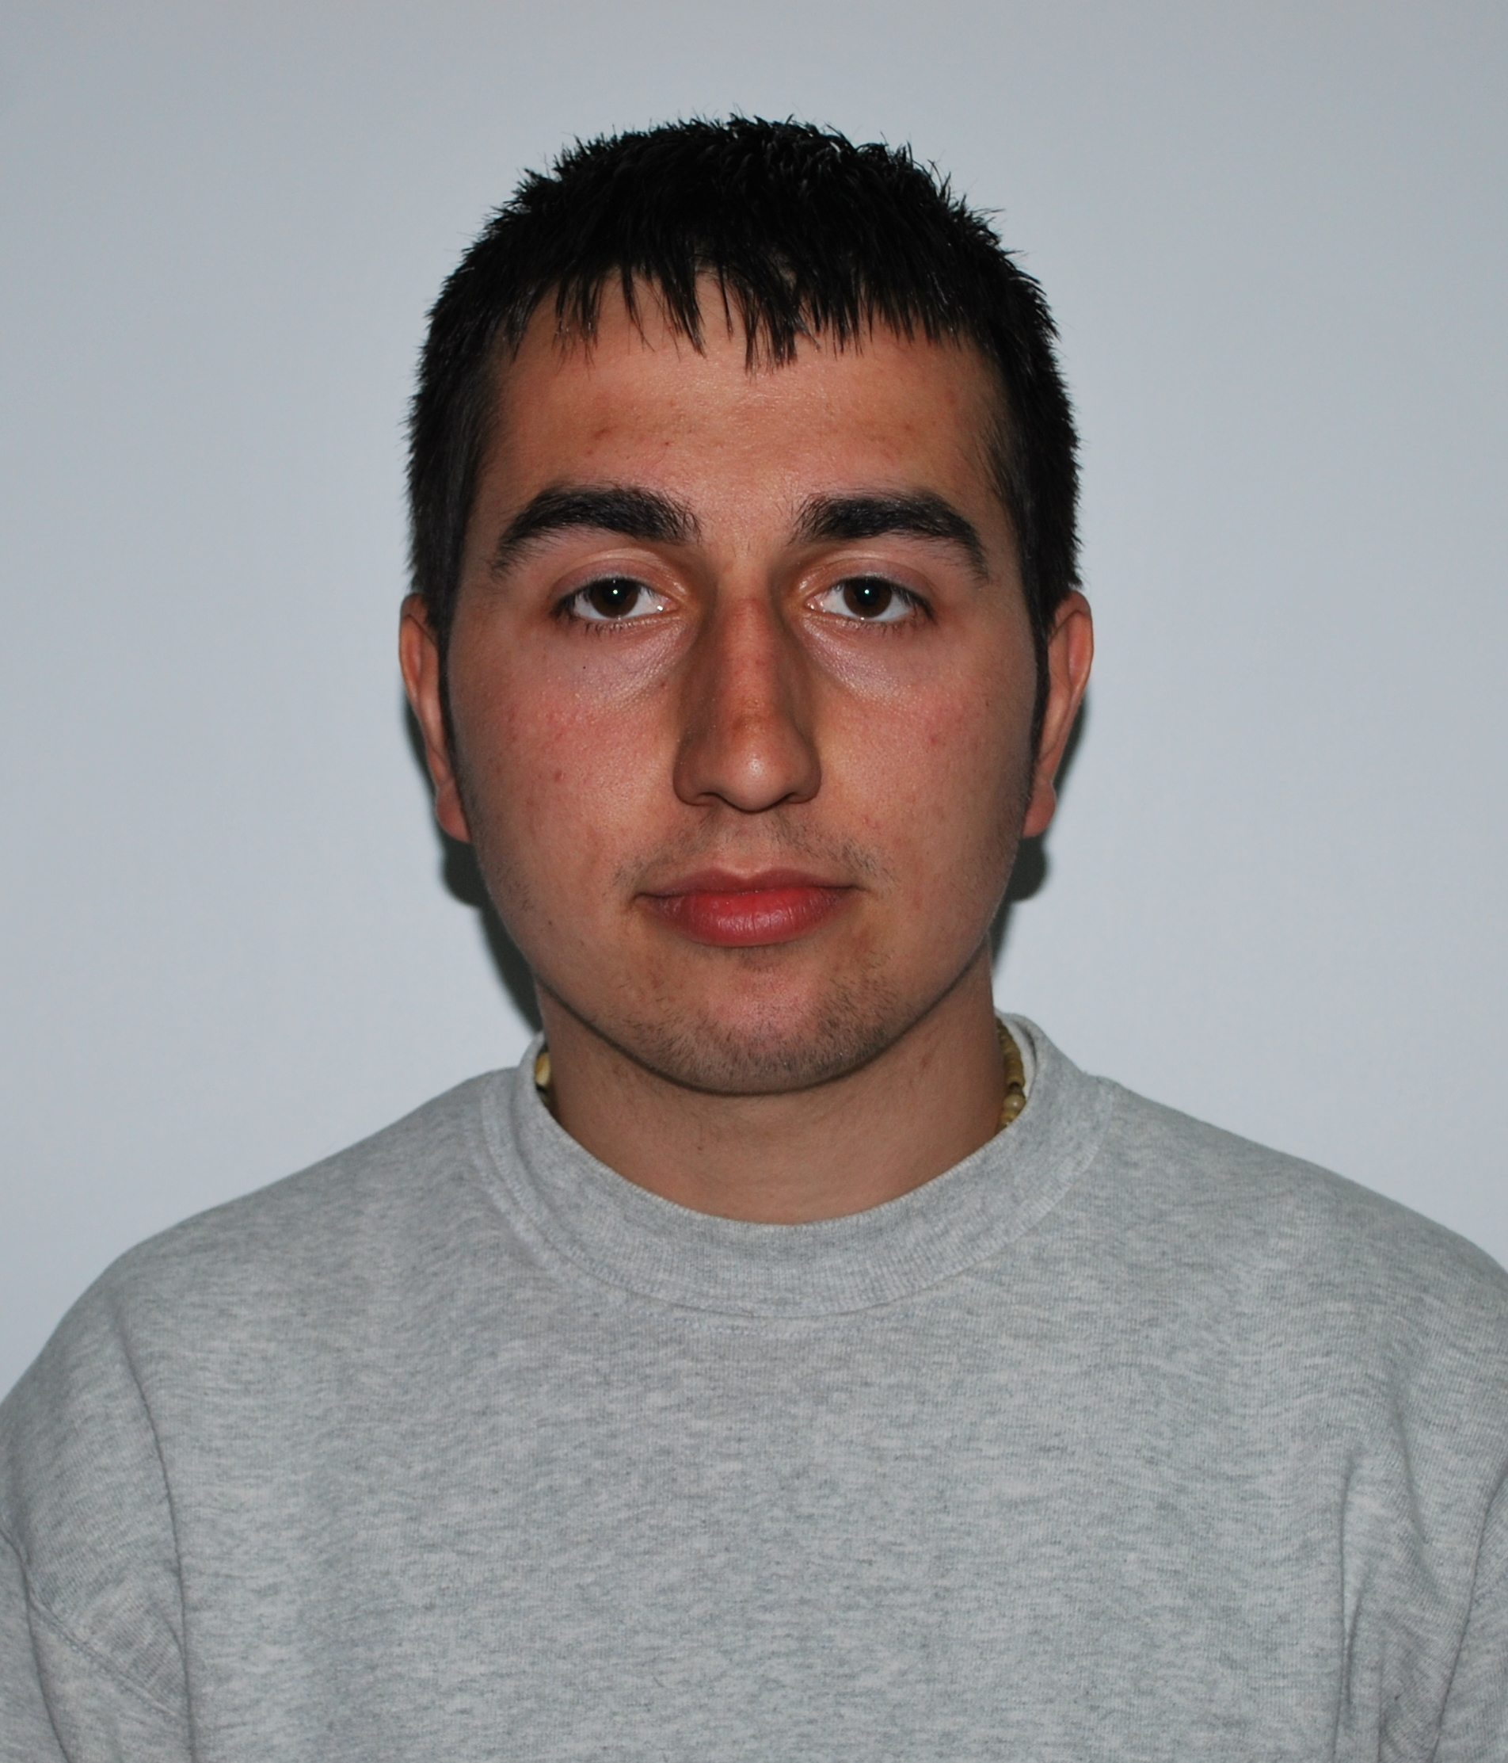
Personal information
First name(s) / Surname(s) |  | SĂRMĂŞAN ALEXANDRU-LAVINIU
Address(es) |  | Nr 8, Bld. Republicii, Resita, Romania
Telephone(s) |  |  |  |  |  |  | Mobile: |  |  |  | 0755023072
E-mail |  | ever_alexandru@yahoo.com
Nationality |  | romanian
Date of birth |  | 09.05.1990
Gender |  | male
Education and training
Dates |  | 2005-2009
Title of qualification awarded |  | Tourism technician, level 3 degree of professional qualification
Principal subjects/occupational skills covered |  | Maths  Study of product and services quality  Accounting  Marketing  Economy  Enterprise economy  Business financing
Name and type of organisation providing education and training |  | Economical College of BANATUL MONTAN RESITA
Personal skills and competences
Mother tongue(s) |  | Romanian
Other language(s) |  | English
Self-assessment |  |  | Understanding |  |  |  |  | Speaking |  |  |  |  | Writing
European level (*) |  |  | Listening |  | Reading |  |  | Spoken interaction |  | Spoken production
English |  |  |  | Experienced user |  | Experienced user |  |  | Basic user |  |  | Independent user |  | Independent user
 |  | (*) Common European Framework of Reference for Languages
Social skills and competences |  | Teamwork experience
Computer skills and competences |  | Word, Excel, Power-Point, Access, C, C++, FoxPro
Artistic skills and competences |  | Graphics
Other skills and competences |  | Hobby: soccer
Driving licence |  | B category
Additional information

