

Europass  Curriculum Vitae |  | 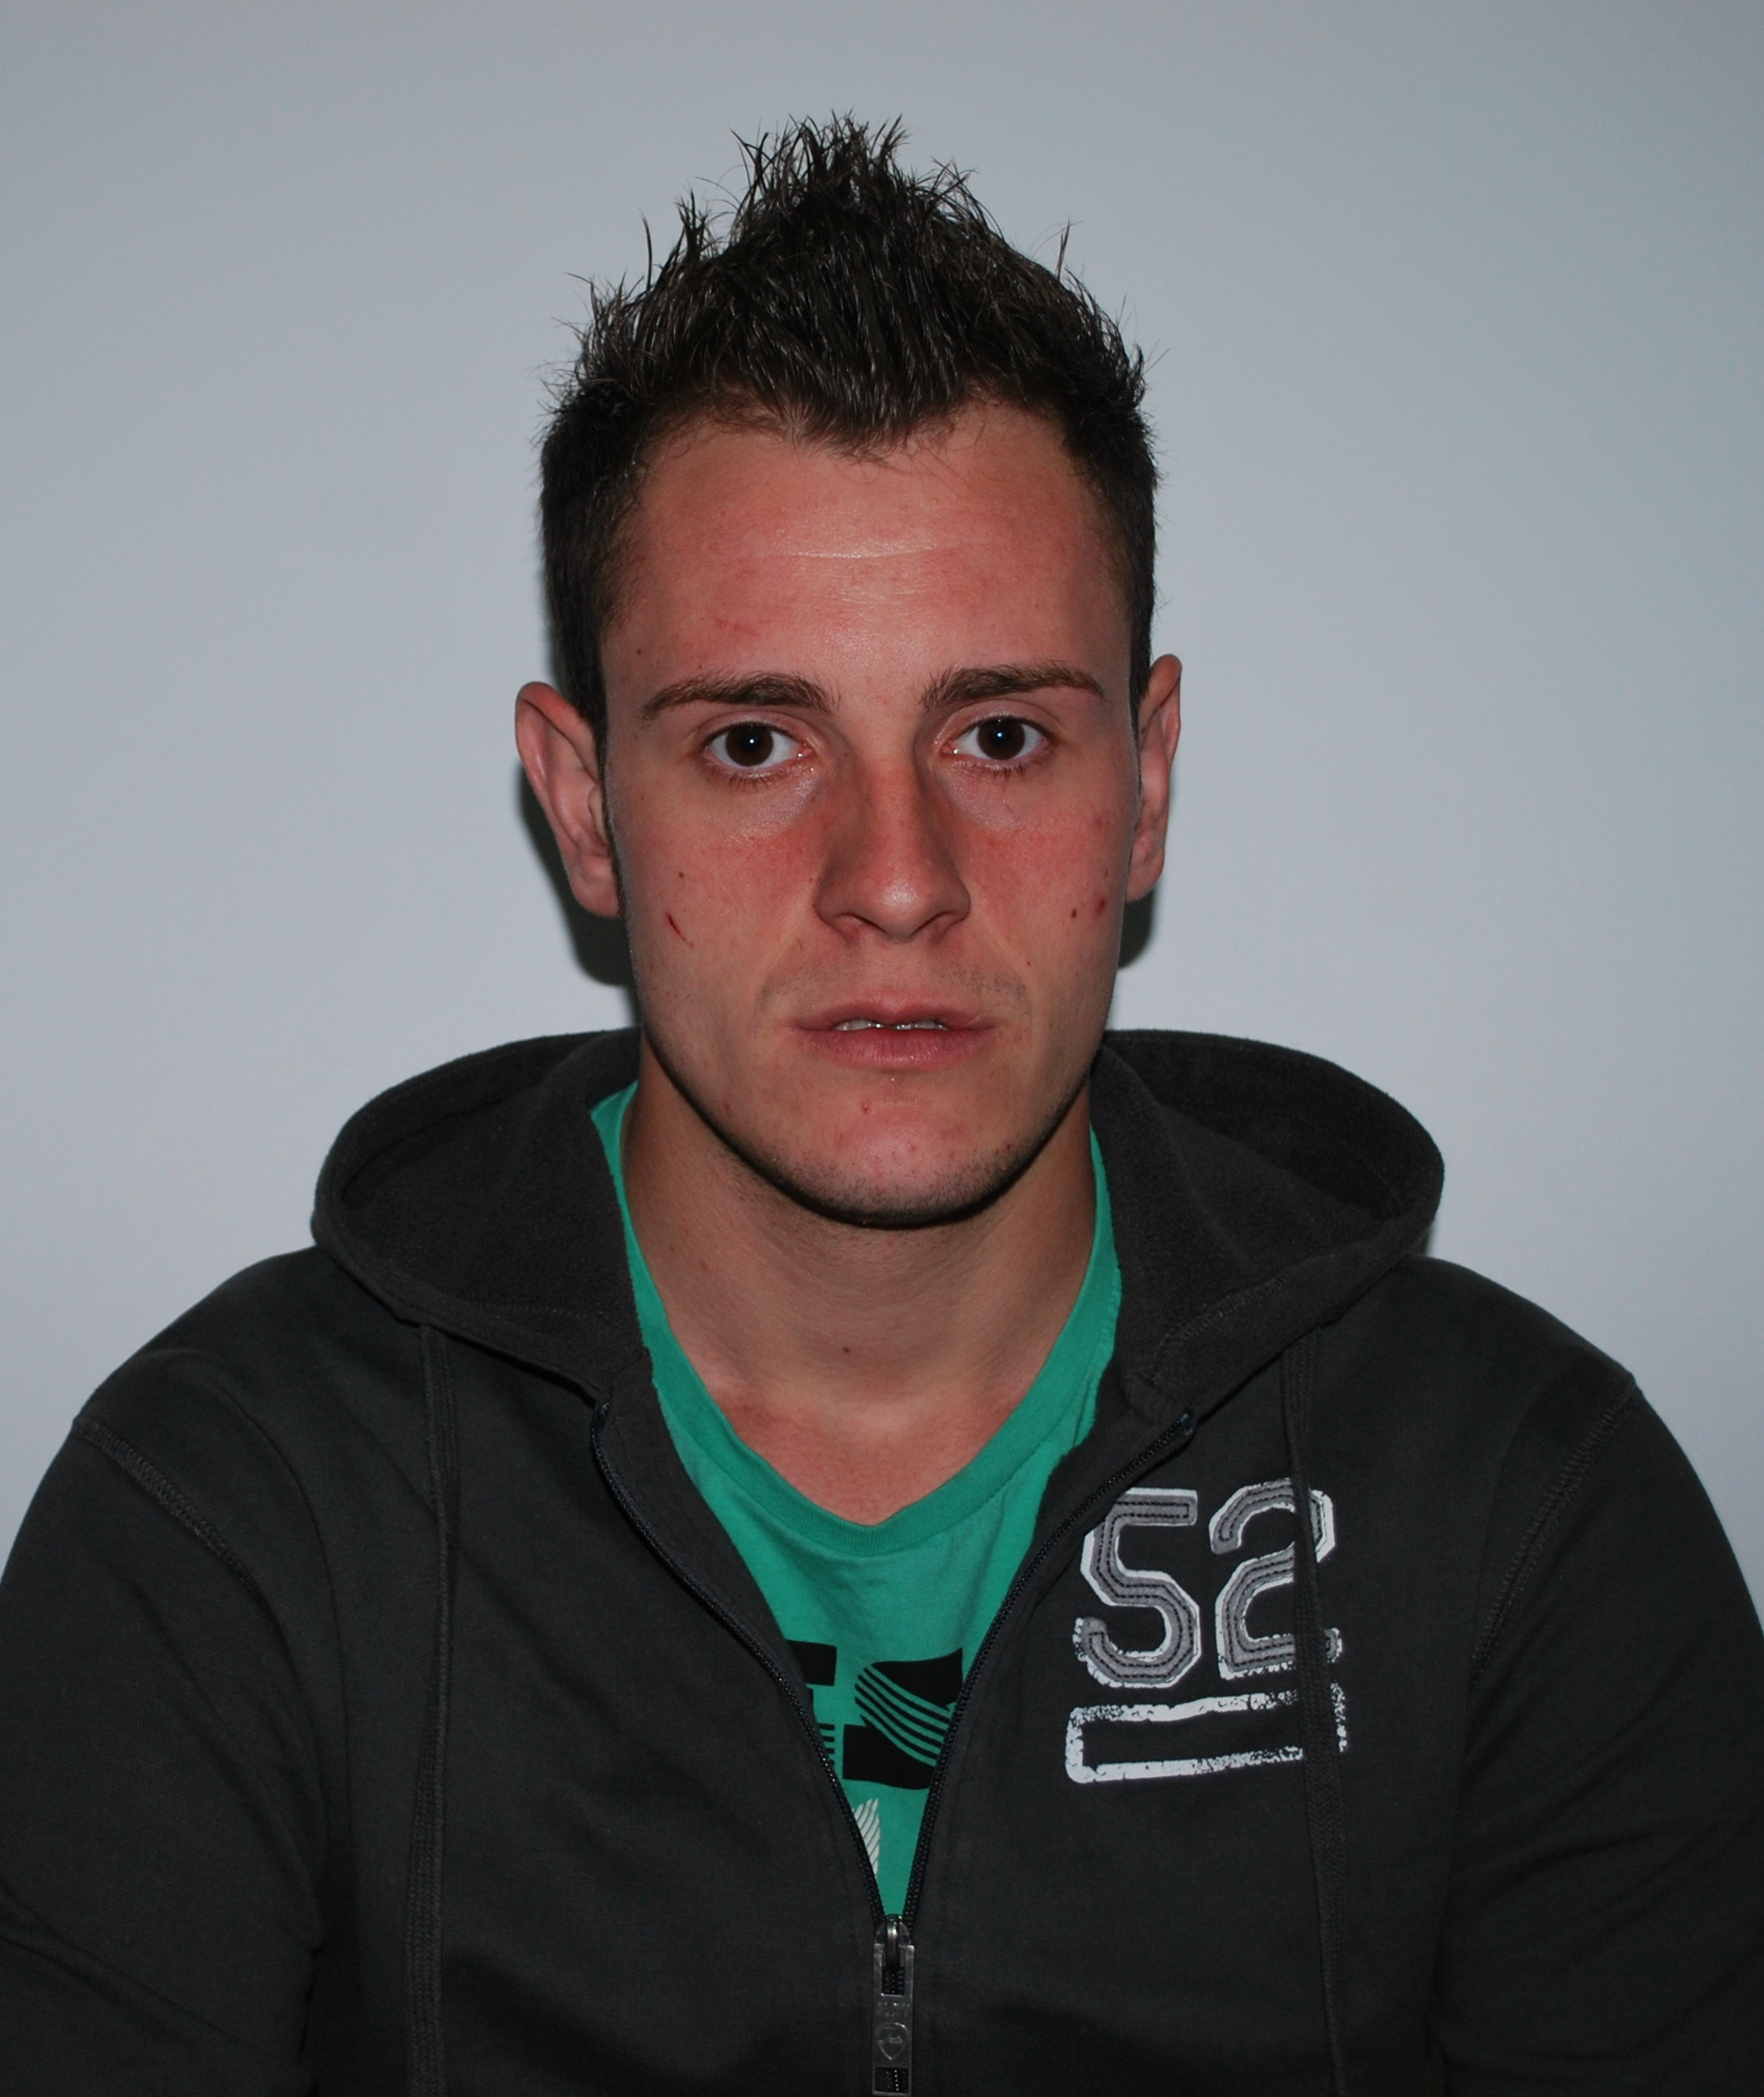
Personal information
First name(s) / Surname(s) |  | Tămaş Alexandru
Address(es) |  | Str. Eftimie Murgu nr.13, sc.1, et.2, ap.15, Reşiţa, cod poştal 320088 România
Telephone(s) |  | Mobile: +40 0745936032
Fax(es)
E-mail |  | Akemann2005@yahoo.com
Nationality |  | Romanian
Date of birth |  | 08.03.1990
Gender |  | Male
Desired employment / Occupational field |  | Student at University Eftimie Murgu Resita, Faculty of Engineering, department: Engineering and Management, field: Economic Engineering in Electrical, Electronic and Power
Work experience
Dates
Occupation or position held
Main activities and responsibilities
Name and address of employer
Type of business or sector
Education and training |  | High School "Traian Vuia” Resita, specialization: Mathematics and Computer Intensive English
Dates |  | 2005-2009
Title of qualification awarded |  | High school graduation certificate  Baccalaureate diploma  Certificate of advanced level language skills in English
Principal subjects/occupational skills covered
Name and type of organisation providing education and training
Level in national or international classification
Personal skills and competences
Mother tongue(s) |  | Romanian
Other language(s)
Self-assessment |  |  | Understanding |  |  |  |  | Speaking |  |  |  |  | Writing
European level (*) |  |  | Listening |  | Reading |  |  | Spoken interaction |  | Spoken production
English |  |  | C1 | Proficient  user | B2 | Independent  user |  | B2 | Independent  user | B1 |  | Independent  user | C1 | Proficient  user
Language
 |  | (*) Common European Framework of Reference for Languages
Social skills and competences
Organisational skills and competences
Technical skills and competences
Computer skills and competences |  | Medium experience with most Mircrosoft Office programmes and some experience with HTML
Artistic skills and competences
Other skills and competences
Driving licence
Additional information
Annexes

