

Europass  Curriculum Vitae |  | 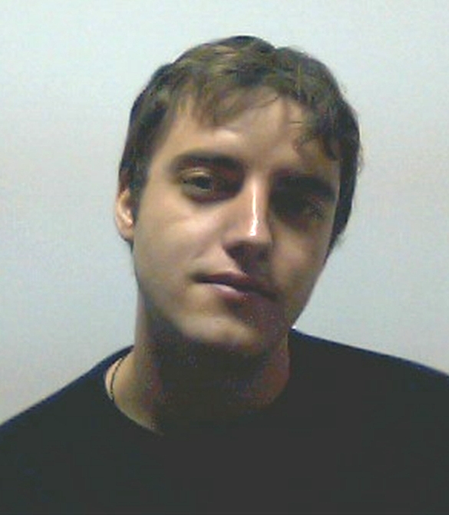
Personal information
First name(s) / Surname(s) |  | ŢEPEŞ Daniel Teofil
Address(es) |  | nr. 70, Str. Colonia I, Postal code 325100, Anina, Caraş-Severin, România
Telephone(s) |  | (remove if not relevant, see instructions) |  |  |  |  | Mobile: |  |  |  | (remove if not relevant, see instructions)
Fax(es) |  | -
E-mail |  | tdany16@yahoo.com
Nationality |  | romanian
Date of birth |  | 10.02.1989
Gender |  | male
Desired employment / Occupational field |  | -
Work experience |  | -
Education and training
Dates |  | 2008 - present
Title of qualification awarded |  | Student in the third year in Economical engineering in the electrical, energetic and electronic domain.
Principal subjects/occupational skills covered |  | Bacalaureat degree: Electro-technical technician
Name and type of organisation providing education and training |  | School group „Mathias Hammer” Anina
Level in national or international classification |  | Third level, Electro-technical technician
Personal skills and competences
Mother tongue(s) |  | Romanian
Other language(s) |  | German
Self-assessment |  |  | Understanding |  |  |  |  | Speaking |  |  |  |  | Writing
European level (*) |  |  | Listening |  | Reading |  |  | Spoken interaction |  | Spoken production
German |  |  | A1 |  | B1 |  |  | A2 |  | A2 |  |  | A2
 |  | (*) Common European Framework of Reference for Languages
Social skills and competences |  | Able to work in a team and under stress, quick adaptability to changes, comunication
Technical skills and competences |  | PC knowledge
Computer skills and competences |  | Hardware – medium level, Software – medium level: installation  Windows XP, Vista, 7; Office (MS, Open Office) –Medium;
Other skills and competences |  | Hobby: PC in general, travelling
Additional information |  | Scientific paper “Optimization of transport lines”, Economical Students Olympics, University Eftimie Murgu

