Curriculum Vitae | 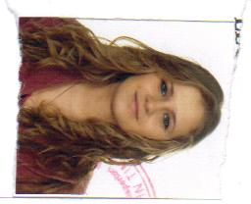
Personal information
First name(s) / Surname(s) | Andreea-Ioana Avădanei
Address(es) | Str.Ioan Slavici,Bl 8C,Timisoara, Romania
Telephone(s) | 0730043061
E-mail | andreea_a16@yahoo.com
Nationality | Romanian
Date of birth | 25/09/1989
Gender | Female
Education and training
Dates | 2008 – present
Title of qualification awarded | Engineering and management
Name and type of organisation providing education and training | Polytechnic University, Timişoara - Management in Production and Transport Faculty
Personal skills and competences
Mother tongue(s) | Romanian
Other language(s) | English, French
Self-assessment |  | Understanding |  |  |  |  | Speaking |  |  |  |  | Writing
European level |  | Listening |  | Reading |  |  | Spoken interaction |  | Spoken production
English |  | B1 | Independent user | B1 | Independent user |  | B1 | Independent user | B1 |  | Independent user | B1 | Independent user
French |  | A1 | Basic User | A1 | Basic User |  | A1 | Basic User | A1 |  | Basic User | A1 | Basic User
Social skills and competences | - Team work  - Initiative  - Good communication skills
Computer skills and competences | Competent with most Microsoft Office programmes and some experience with AutoCAD, Photoshop
Additional information | References available upon request
Annexes | Cetificate in Insurance

